**CS553 Project**

**Understanding the Cost of Cloud Computing**

Cloud computing, one of the scalable infrastructure for computing available today is catered by means of service. Amazon being one of the companies who provide these services tend to follow a on demand pricing business model. This project aims at comparing amazon on demand cloud service against the cost to set up a private infrastructure.

The report is formed in such a way that comparison between the two infrastructure options are evident. For the cloud computing setup, we have considered three configurations described in the following format.

Configuration Details

Amazon Public cloud setup cost estimation

Private cloud setup cost estimation

And finally, at the end we will compare all three configurations to showcase which is better and why

**Configuration 1**

|  |  |
| --- | --- |
| Config 1 | Description |
| Compute Servers | 32 k cores |
| Memory | 256 TB |
| Disk | 50 PB HDD |
| Network | 10 Gb/sec |
| Distributed storage (100GB/sec throughput) | 100 PB |

*Table 1: configuration 1 specification*

**Amazon public on demand cloud computing cost**

Instance chosen: d2.8xlarge

Each instance configuration:

36 cores, 244 GiB of Memory and 24* 2000 HDD at the cost of $5.52 per hour

**1.Instance Calculation**

For the configuration mentioned in the above table. The required instances are computing below

CPU

32K cores

1 d2 instance CPU’s = 36 vCPU

vCPU to cores = vCPU

= 36 cores

Instances required for 32 K core = 32000/36

= 889 d2.8xlarge instances --------> a

Memory

256TB in GB = 262,144 GB

1 d2 instance Disk capacity = 244 GiB

244 GiB in GB = 244* 1.074 = 262.06 GB

Instances required for 256TB = 262,144 /262.06

= 1,001 d2.8xlarge instances --------> b

Disk

50PB in GB = 52,428,800 GB

1 d2 instance Disk capacity = 48,000 GB

Instances required for 50PB = 52,428,800/48000

= 1,093 d2.8xlarge instances --------> c

Total number of d2.8xlarge instances required = max ( a, b, c)

= 1,093 instances

**2.Distributed Storage**

S3 standard storage pricing per month = $0.021 per GB

100 PB in GB = 104,857,600 GB

Storage cost for 5 years = 0.021 * 104,857,600 * 12 * 5

= $ 132,120,576

**3.Total Cost calculation**

1 D2.8xlarge instance cost

36 cores, 244 GiB of Memory and 24* 2000 HDD at the cost of $5.52 per hour

1,093 instances cost per hour = 5.52 * 1,093

= $ 6033.36

1,093 instances cost for 5 years = $9,814.56 * 24 * 365 * 5

= $ 264,261,168

Total cost = distributed storage cost + d2.8xlarge instance cost

= $ 132,120,576 + $ 264,261,168

**= $ 396,381,744**

**Private Cloud setup cost estimation**

Each rack used: Iris 2482

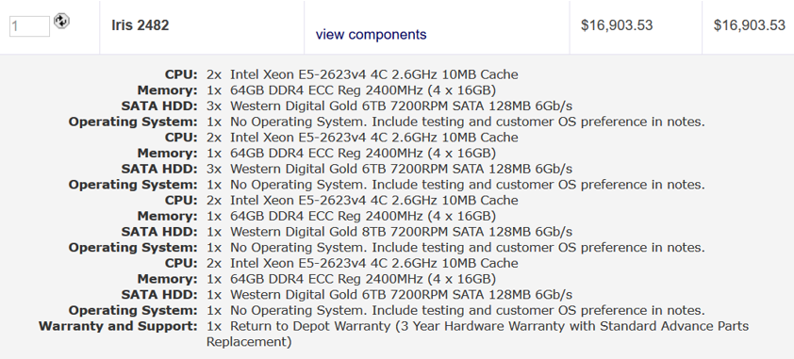

|  |  |  |  |  |
| --- | --- | --- | --- | --- |
|  | Description | Price per Item | Quantity | Total Price |
| Compute Servers | Iris 2482 | $ 16,903.53 | 1,000 | $ 16,903,530 |
| Network Switches | Dell Z9000 switches | $ 862.62 | 71 | $ 61,246.02 |
| Network Cables | Dell Networking Cable,40GbE (QSFP+) to 4 x 10GbE SFP+ | $ 720 | 256 | $ 184,320 |
| Network Cables | Dell Networking, Cable, QSFP+ to QSFP+, 40GbE | $ 590 | 992 | $ 585,280 |
| Storage Servers | STX-CL XE72-2460 | $ 43,934 | 237 | $ 10,412,358 |
| Electric Power | 1200W (compute nodes)+ 1200W(cooling) over 5 years | N/A | N/A | $ 12,614,400 |
| Cooling | Cooler master v1200 | $ 303 | 1,000 | $ 303,000 |
| Administration | 1 per 1000 nodes over 5 years | $ 500,000 | 1 | $ 500,000 |
| TOTAL | N/A | N/A | N/A | $ 41,564,134.02 |

**Configuration 2**

|  |  |
| --- | --- |
| Config 1 | Description |
| Compute Servers | 1 Million * 2 cores |
| Memory | 1 Million * 15 GB RAM |
| Disk | 1 Million * 32 GB SSD |
| Network | 1 Million * 1GB/sec |
| Distributed storage (10GB/sec throughput) | 10 PB |

*Table 2: configuration 2 specification*

**Amazon public on demand cloud computing cost**

Instance chosen: r3.large

Each instance configuration:

|  |  |  |  |  |
| --- | --- | --- | --- | --- |
| **Name** | **vCPU** | **Mem(GiB)** | **HDD/SSD(GB)** | **cost** |
| **R3.large** | **2** | **15** | **1*32SSD** | **$0.166/Hour** |

For the configuration mentioned in table 2. The required instances are computed below

**1.Instances Required**

For the configuration mentioned in first table

CPU

2 million cores

1 r3.large instance CPU’s = 2 vCPU

vCPU to cores = vCPU

= 1 core

Instances required for 2Million core = 2,000,000/2

= 1,000,000 r3.large instances --------> a

Memory

15 Million GB

1 r3.large instance Disk capacity = 15 GiB

15 GiB in GB = 15 * 1.074 = 16.11 GB

Instances required for 15 Million GB = 15000000/16.11

= 931,099 r3.large instances --------> b

Disk

32 Million GB

1 r3.large instance Disk capacity = 32 GB

Instances required for 32 Million GB = 32000000/32

= 1,000,000 r3.large instances --------> c

Total number of r3.large instances required = max ( a, b, c)

= 1,000,000 instances

**2.Distributed Storage**

S3 standard storage pricing per month = $0.021 per GB

10 PB in GB = 10485760 GB

Storage cost for 5 years = 0.021 * 10485760 * 12 * 5

= $ 13,212,057.6

**3.Cost calculation**

1 r3.large instance cost

36 cores, 244 GB of Memory and 24* 2000 HDD at the cost of $5.52 per hour

1,000,000 instances cost per hour = 0.166 * 1,000,000

= $166,000

1,000,000 instances cost for 5 years = $166,000* 24 * 365 * 5

= $7,270,800,000

Total cost = distributed storage cost + r3.large instance cost

= $13,212,057.6 + $7,270,800,000

= $ 7,284,012,057.6

**Private Cloud setup cost estimation**

Each rack used: Iris 2482

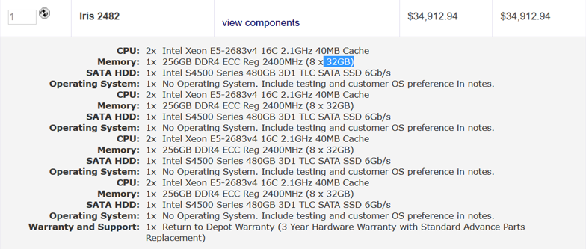

|  |  |  |  |  |
| --- | --- | --- | --- | --- |
|  | Description | Price per Item | Quantity | Total Price |
| Compute Servers | Iris 2482 | $ 34,912.94 | 16,667 | $ 581,893,970.98 |
| Network Switches | Dell Z9000 switches | $ 862.62 | 1,565 | $ 1,350,000.3 |
| Network Cables | Dell Networking Cable,40GbE (QSFP+) to 4 x 10GbE SFP+ | $ 720 | 16,688 | $ 12,015,360 |
| Network Cables | Dell Networking, Cable, QSFP+ to QSFP+, 40GbE | $ 590 | 16,688 | $ 9,845,920 |
| Storage Servers | STX-CL XE72-2460 | $ 43,934 | 24 | $ 1,054,416 |
| Electric Power | 1200W (compute nodes)+ 1200W(cooling) over 5 years | N/A | N/A | $ 210,244,204.8 |
| Cooling | Cooler master v1200 | $ 303 | 16,667 | $ 5,050,101 |
| Administration | 1 per 1000 nodes over 5 years | $ 500,000 | 17 | $ 8,500,000 |
| TOTAL | N/A | N/A | N/A | $ 829,953,973.08 |

**Configuration 3**

|  |  |
| --- | --- |
| Config 3 | Description |
| Compute Servers | 1 exaflop mixed precision |
| (NVIDIA V100 GPUs) | 8 GPU/node(64cores/node) |
| Memory | 8GB/core(512GB/node) |
| Disk |  |
| Network | 10Gb/s per GPU(100Gb/s should work) |
| Distributed storage | 1 PB |

*Table 3: configuration 3 specification*

|  |  |  |  |  |  |  |
| --- | --- | --- | --- | --- | --- | --- |
| **Name** | **GPU’s per node** | **(vCPU)** | **Mem(GB)** | **HDD/SSD(GB)** | **Precision(mixed) / GPU** | **cost** |
| Each p3.16xlarge | 8 | 64 | 488 | N/A | 125 TF | 24.48/hr |

*Table 4: Each p3.16xlarge instance*

1.Distributed Storage

S3 standard storage pricing per month = $0.021 per GB

1 PB in GB = 1,048,576 GB

Storage cost for 5 years = 0.021 * 1048576 * 12 * 5

= **$ 1,321,205.76**

2.Instances Required

1 exaflop = 1,000,000 TF

Each instance performance = GPU’s per node * mixed precision/GPU

= 8 * 125 TF

= 1000TF

Instances required = 1,000,000 TF/1,000 TF

**= 1,000 instances**

Cost of total nodes = 1,000 * 24.48 * 24 * 365 * 5 = $1,072,224,000

512GB /node = 488 GB/node * 1.05

Inclusive of instance count from previous calculation = 1.05 * 1,000 =1050

Cost of total nodes = 1,050 * 24.48 * 24 * 365 * 5

**=$ 1,125,835,200**

3.Total Cost

**Total cost = distributed storage cost + compute cost**

= $ 1,321,205.76 + $1,125,835,200

**Total cost** **= $1,127,156,405.76**

**Private Cloud setup cost estimation**

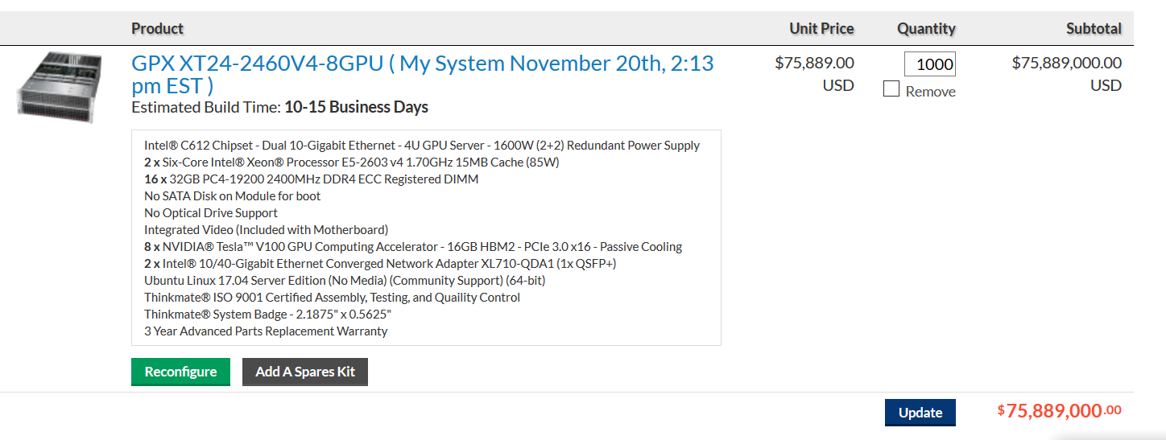

1 exaflop = 1,000,000 TF

Each instance perf = 8 * 125 TF = 1000TF

Instances required = 1,000,000 TF/1,000 TF = 1,000 instances

**Cost of total nodes =** 1,000 instances* $75889

= **$75,889,000**

**Total Network cost =** $ 61,246.02+$ $1,189,440

= $1,250,686.02

**Distributed storage calculation**

**Each node = 72 * 6 TB HDD SATA= 432 TB/node**

**Instances required for 1PB = 1 * 1024 /432 = 3 instances**

**Total cost = instances * cost per instance = 3 * 43,934 = 131,802**

**Performance**

**100GB/sec**

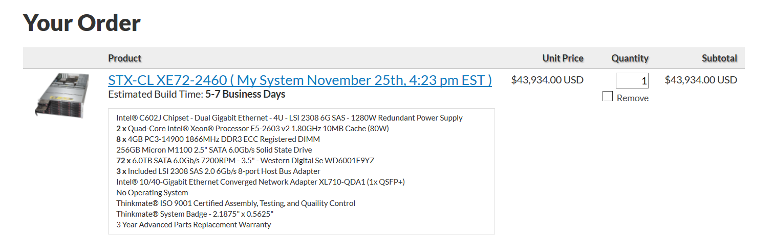

|  |  |  |  |  |
| --- | --- | --- | --- | --- |
|  | Description | Price per Item | Quantity | Total Price |
| GPU Servers | GPX XT24-2460V4-8GPU | $75889 | 1,000 | $75,889,000 |
| Network Switches | Dell Z9000 switches | $ 862.62 | 95 | $ 61,246.02 |
| Network Cables | Dell Networking, Cable, QSFP+ to QSFP+, 40GbE | $ 590 | 2016 | $ 1,189,440 |
| Storage Servers | STX-CL XE72-2460 | $ 43,934 | 3 | $131,802 |
| Electric Power | 3000W (compute nodes)+ 3000W(cooling) over 5 years | N/A | N/A | $ 12,614,400 |
| Cooling | Cooler master v1200 | $ 303 | 1000 | $ 303,000 |
| Administration | 1 per 1000 nodes over 5 years | $ 500,000 | 1 | $ 500,000 |
| TOTAL | N/A | N/A | N/A | $ 90,688,888.02 |

**Summary Table:**

|  |  |  |  |
| --- | --- | --- | --- |
|  | **Configuration 1** | **Configuration 2** | **Configuration 3** |
| Public Cloud (including EC2 and S3) Cost over 5 years, 24/7 operation, with 100% usage | $396,381,744 | $7,284,012,057.6 | $1,127,156,405.76 |
| Private Cloud cost over 5 years, 24/7 operation, with 100% usage | $ 41,564,134.02 | $829,953,973.08 | $90,688,888.02 |
| What utilization must be achieved with the private cloud to make the private cloud option more attractive than the public cloud? |  |  |  |